**ENR 261 Fall 2016 Chapter 4 Homework**

**General Instructions:**

Save your all your Matlab files for this chapter in a folder named **Ch04** located inside your ENR261-001 folder on your student storage drive. Copy your ENR261-001 folder and all contents to your USB Memory Stick.

**When you complete a tutorial you need to do the following:**

1. Print out your script (.m) file and output by first clicking on **File/Publish** then File/Print. If your program has an input statement you will have to print the Editor, Command, and Figure windows individually using File/Print.

2. Three-hole punch the printout

3. Present your printout along with your grading sheet to your instructor for checking in class

4. After all files have been checked by the instructor place your printouts and the grade sheet in your portfolio.

5. Use the required file names for each script file.

Required File Name: **Tutorial_04_1.m**

1. Save the Excel file: **Ch04_Data_Sp10.xlsx** from the ENR261 M: Drive folder to your Ch04 Matlab HW file.

2. Create the following Matlab program.

3. After running the program, publish this program **and** print out the **OldResistors** sheet from **Ch04_Data_Sp10.xlsx**.

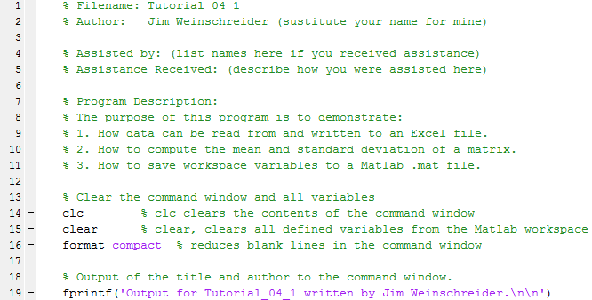

Continued on the Next Page

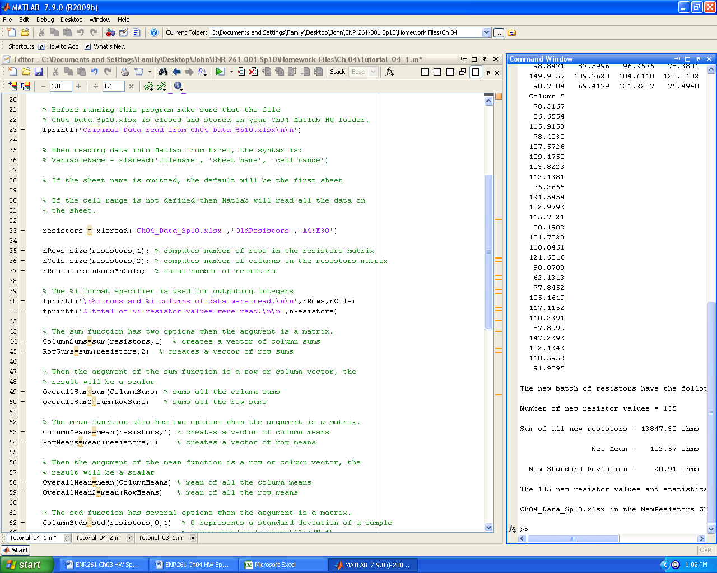 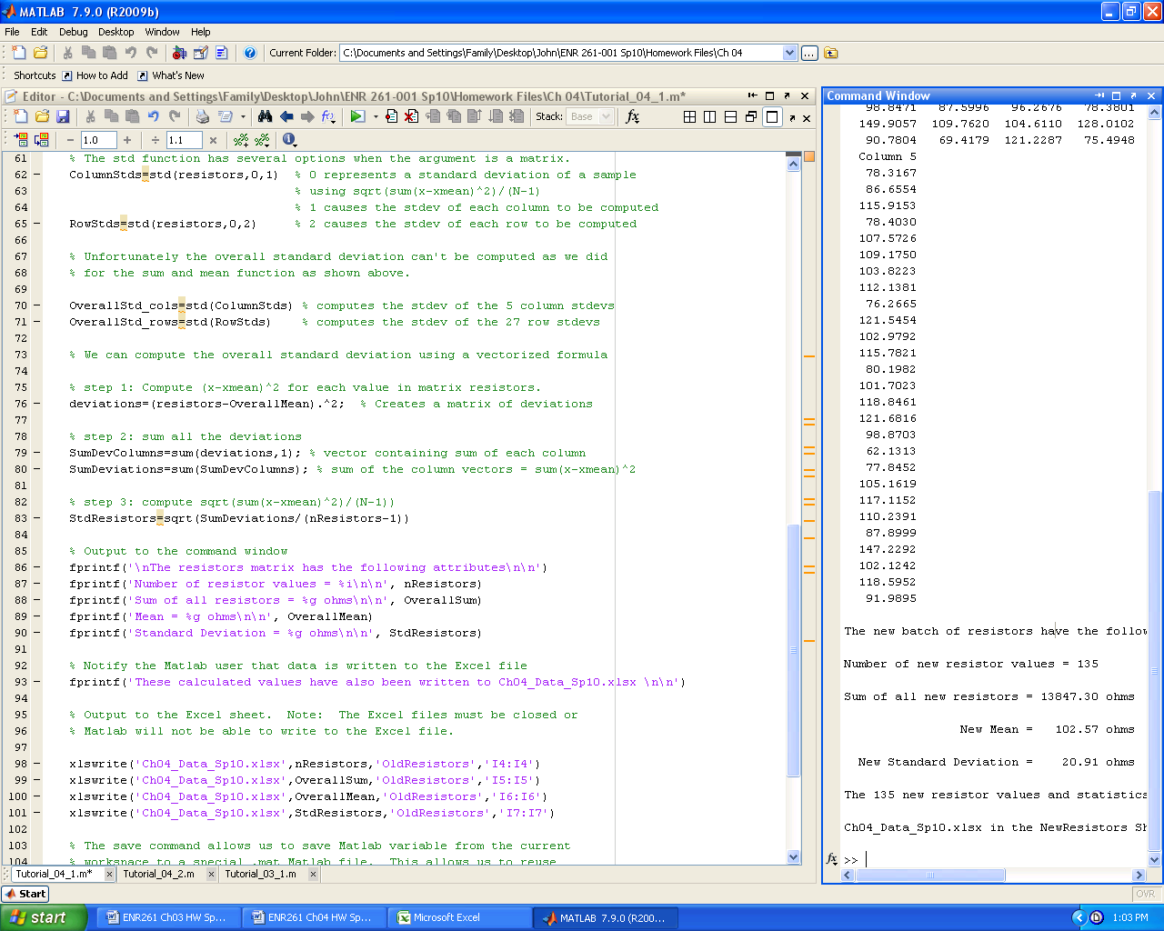

Continued on the Next Page

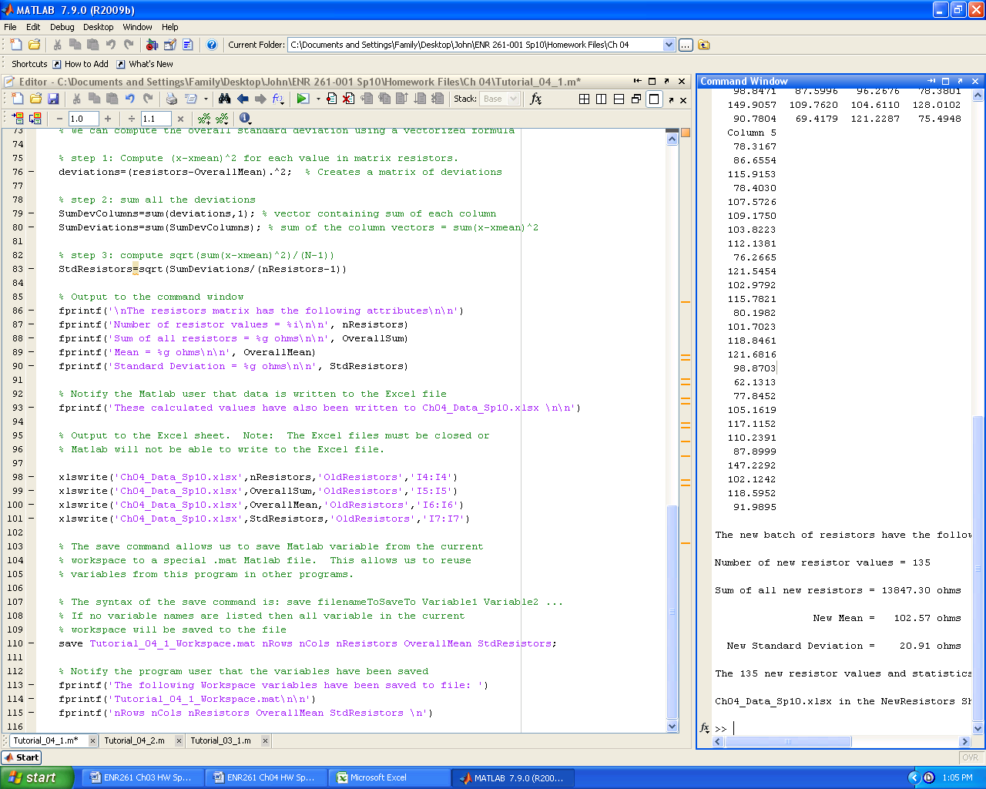

Required File Name: **Tutorial_04_2.m** After running the program, publish this program **and** print out the **NewResistors** sheet from **Ch04_Data_Sp10.xlsx**.

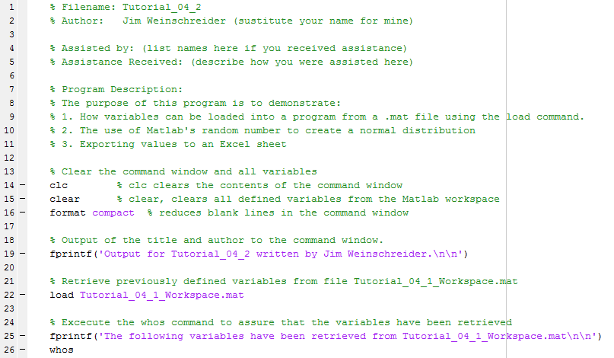Continued on the Next Page

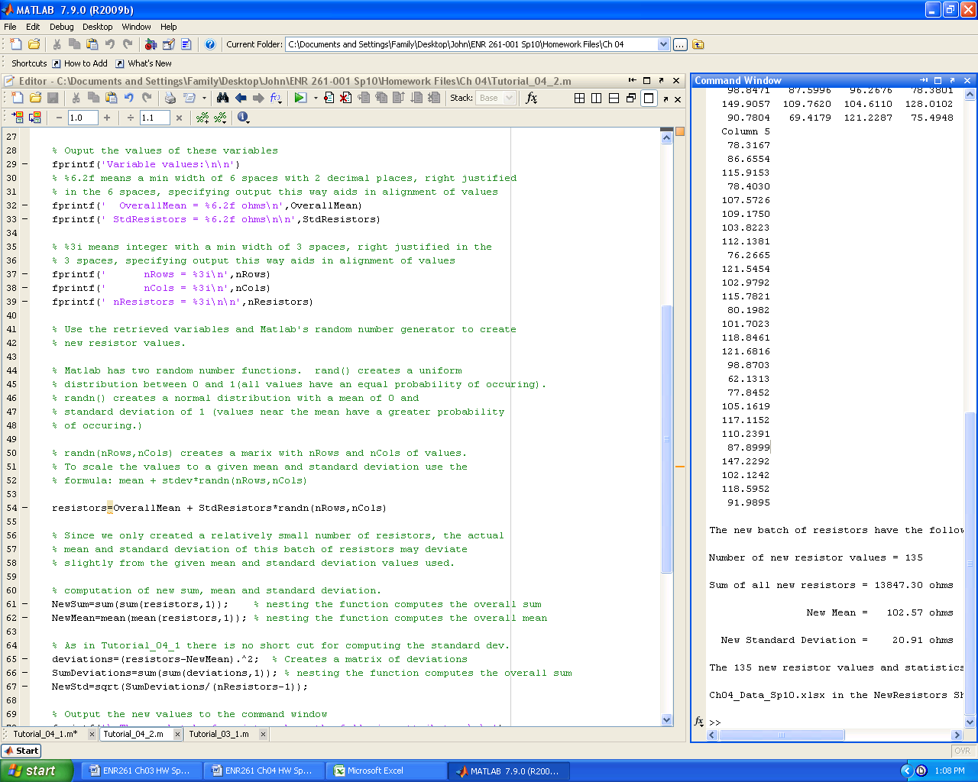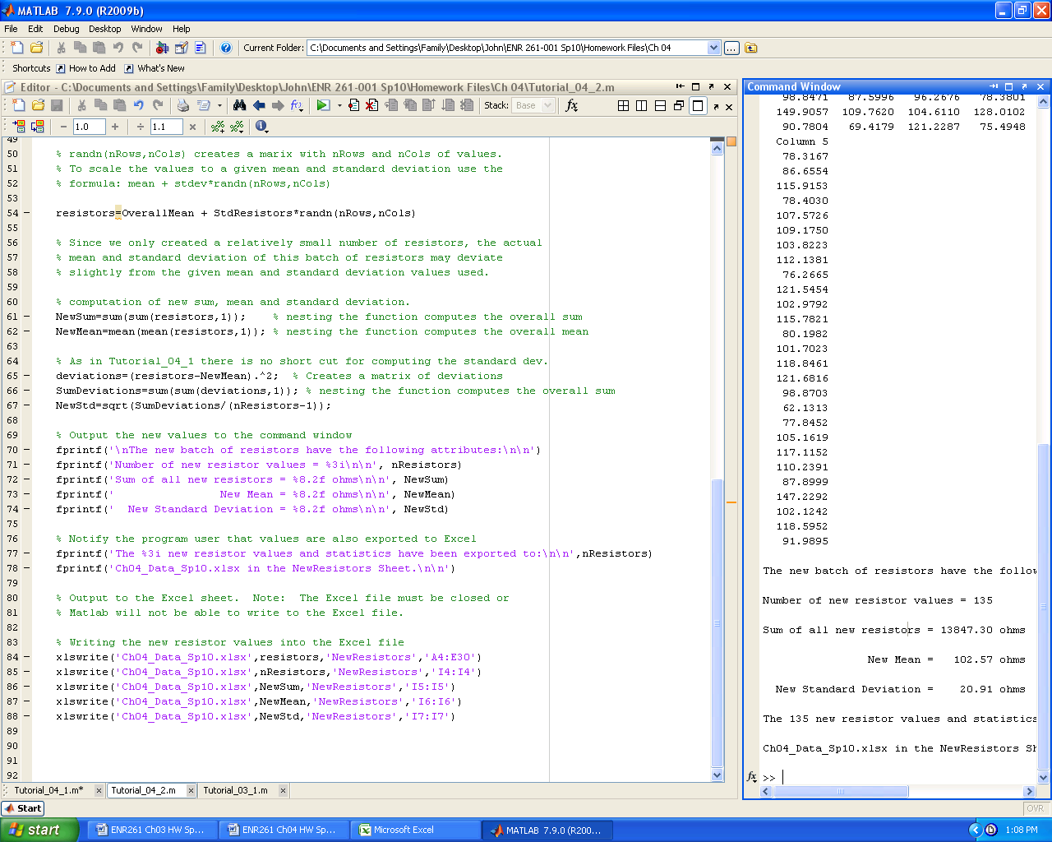

Required File Name: **Tutorial_04_3.m**

1. Save the text file: **NothernHemTempIndex.txt** from the ENR261 M: Drive folder to your Ch04 Matlab HW file.

2. Create the following Matlab program.

3. After running the program, publish this program **and** print out the **Tutorial_04_3_Output.txt** file.

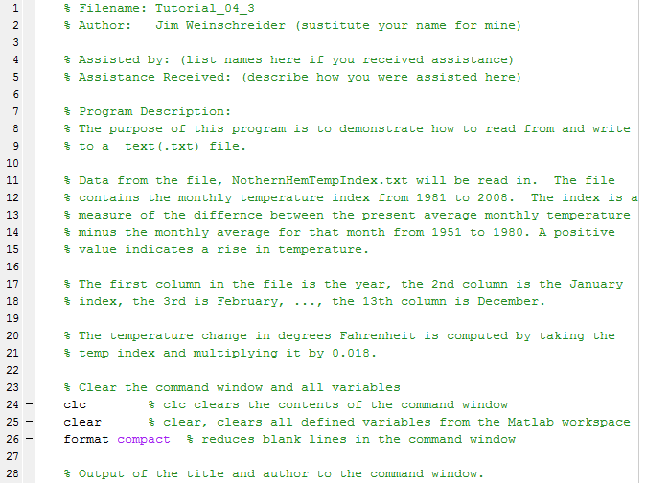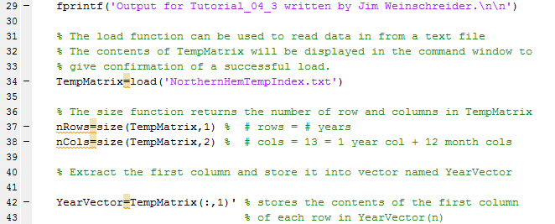

Continued on the Next Page

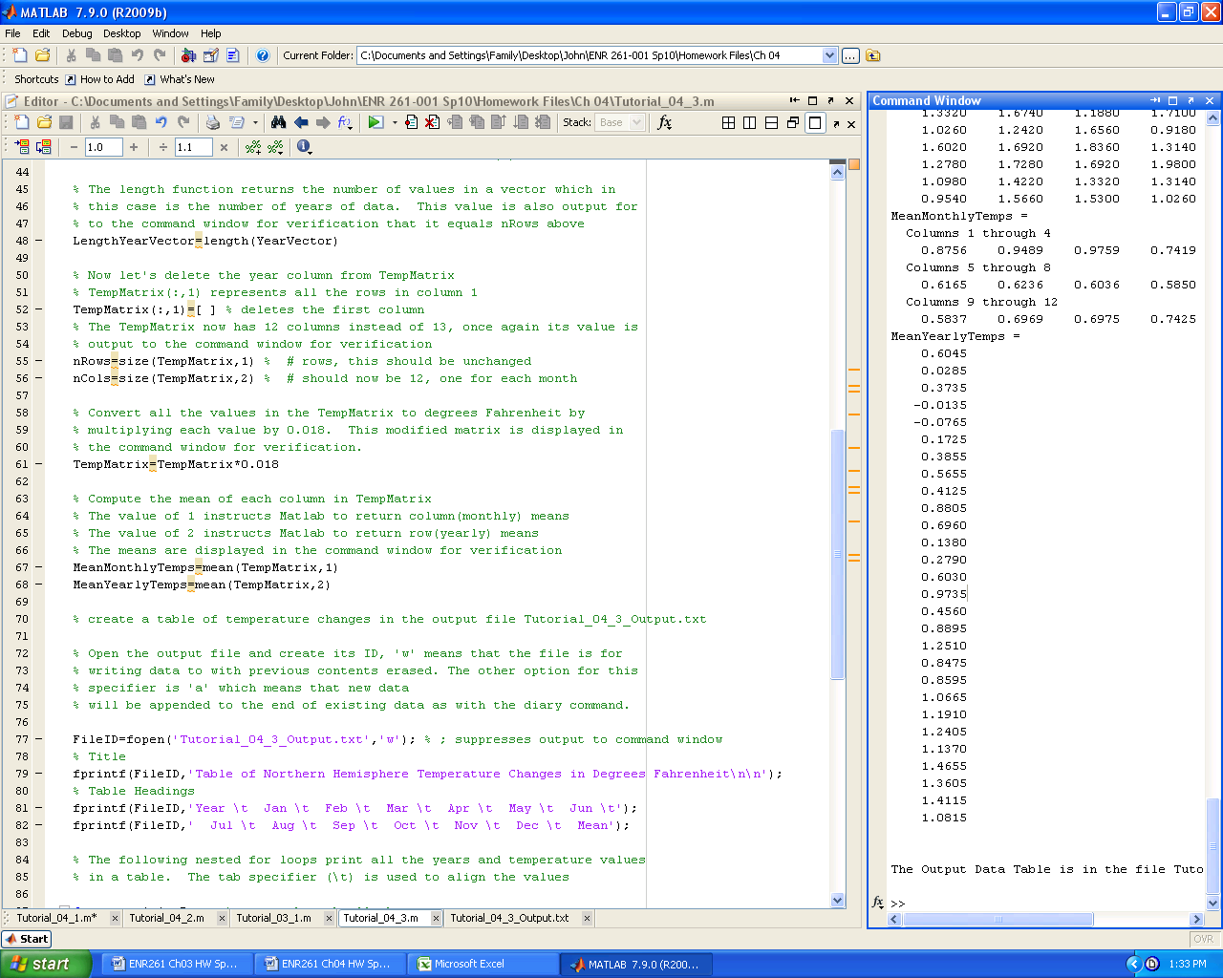 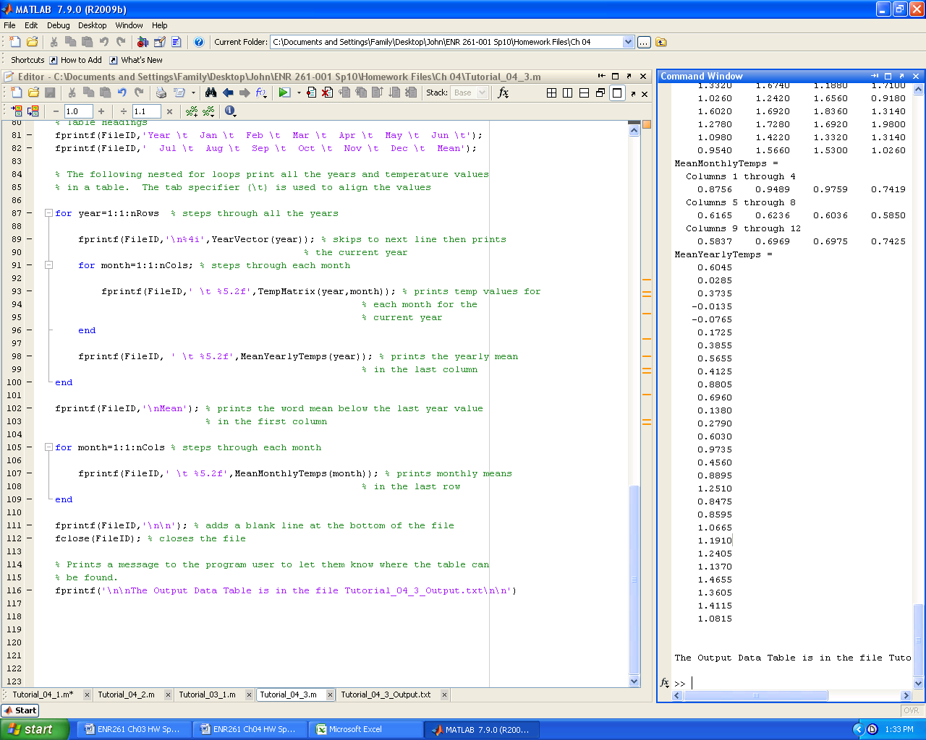

Required File Name: **Program_04_1.m**

1. Save the Excel file: **Ch04_Data.xlsx** from the ENR261 M: Drive folder to your Ch04 Matlab HW file.

2. Create a Matlab program that reads the **Change Due** data from the **Coins** sheet in **Ch04_Data_Sp10.xlsx** and performs the following operations. Hint: See the feet and inches example on page 108 of the text

* Computes the number of quarters, dimes, nickels, and pennies that will equal the value of the change due with the least number of coins.
* Computes the number of occurrences of each coin total (how many times that 1,2,…,9 coins were needed to make the required change)
* Produces the output in the command window of Matlab as shown below
* Writes the calculated values to the **Coins** sheet in the **Ch04_Data_Sp10.xlsx** spreadsheet**.**

3. After running the program, publish the program and print out the **Coins** sheet of **Ch04_Data_Sp10.xlsx**.

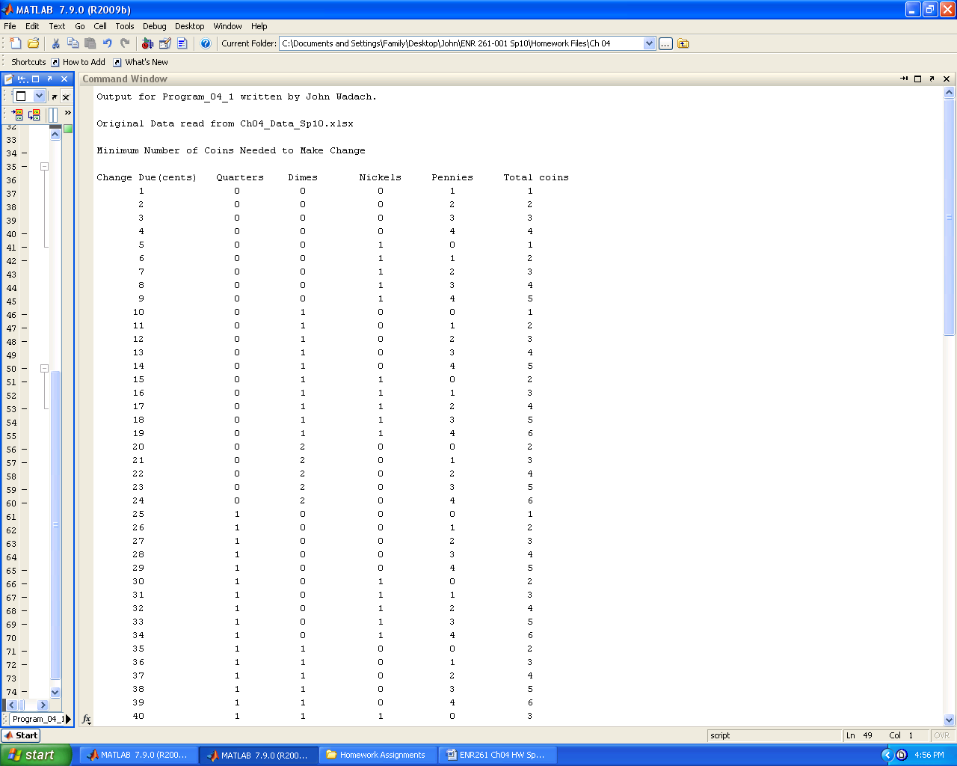

<<Values from 12 cents to 89 cents not shown>>

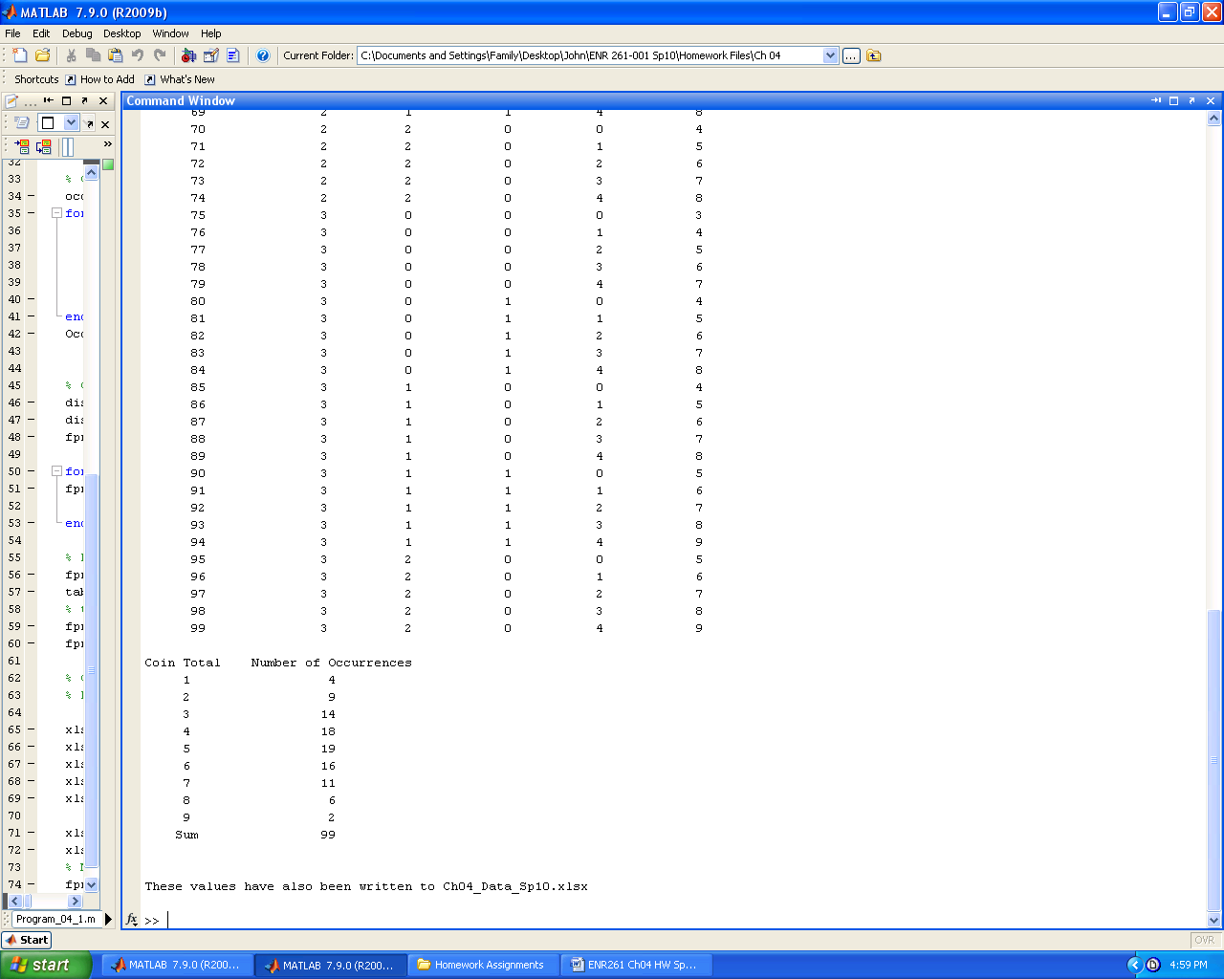

Required File Name: **Program_04_2a.m**

1. Save the text file: **RawGrades.txt** from the ENR261 M: Drive folder to your Ch04 Matlab HW file.

2. Create a Matlab program that performs the operations outlined below.

The purpose of this program is to read raw grades from the file **RawGrades.txt**

and compute the numerical average and the letter grade for each student.

The results will be displayed both in the command window and written to the file: **FinalGrades.txt**

The data file contains six columns in the following order from left to right:

Student Number, Tutorial Ave, Program Ave, Quiz Ave, Portfolio Ave, Presentation Grade.

Numerical Averages are computed according to the formula below.

Tutorial Ave 20%, Program Ave 20%, Quiz Ave 40%, Portfolio Ave 15%, Presentation Grade 5%.

The course average must then be **rounded** to the nearest tenth (0.1) of a point and not just displayed to one decimal place.

Letter grades are assigned based on the following curve.

A >= Mean Numerical Average + 1.5* Standard Dev of Numerical Averages

B >= mean + 0.5*Stdev and < mean + 1.5*Stdev

C >= mean - 0.5*Stdev and < mean + 0.5*Stdev

D >= mean - 1.5*Stdev and < mean - 0.5*Stdev

F < mean - 1.5*Stdev

3. After running the program, publish the program and print out **FinalGrades.txt**.

4. Sample contents of FinalGrades.txt for the first 20 students (students 10121 to 10150 are not shown below).

